Theme: Solar System
Grade Level: 3rd

THEATRE:
Form of Drama, Movement, or Dance
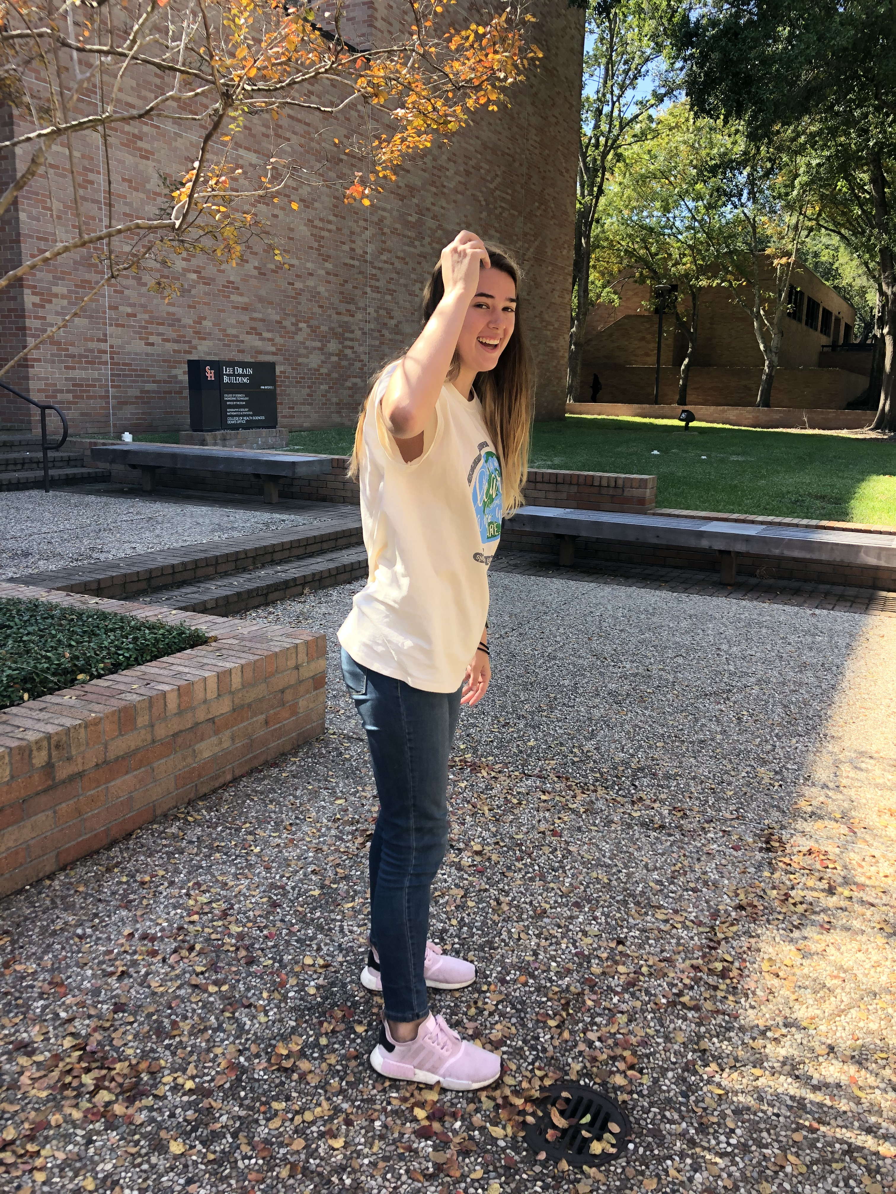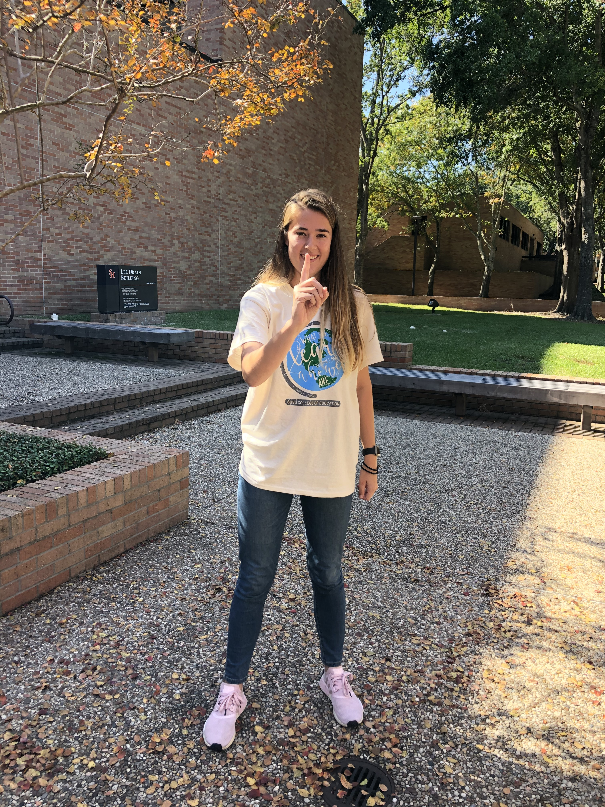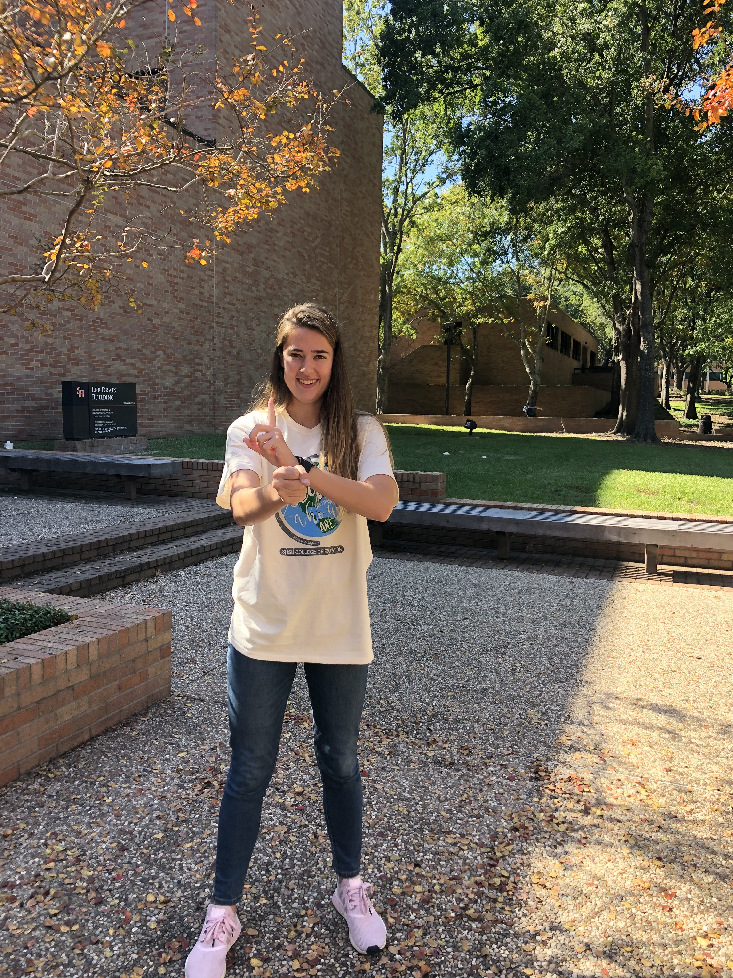

- Rotation and Revolution Movements by Megan Miller
- The movements above will help strengthen the students’ learning. It will also help improve their balance, motor skills, brain function, and cognition. Acting out the vocabulary words helps students memorize and retain the information better. The students will decide on what motions they want to demonstrate for each word: rotate and revolution. Above are examples of different movements the students might do for each word.
- §112.14. Science, Grade 3, Beginning with School Year 2010-2011. (8) Earth and space. The student knows there are recognizable patterns in the natural world and among objects in the sky. The student is expected to: (C) construct models that demonstrate the relationship of the Sun, Earth, and Moon, including orbits and positions; and (D) identify the planets in Earth's solar system and their position in relation to the Sun.

- §117.13. Theatre, Grade 3
(2) Creative expression/performance. The student interprets characters, using the voice and body expressively, and creates dramatizations. The student is expected to: (A) demonstrate safe use of movement and voice.
- The learner will be able to know the difference between rotation and revolution. The students will understand and be able to demonstrate on how the earth moves around the sun. They will gain a better understanding on how days, years, and seasons happen.

Lesson Plan
Engagement/Connecting to Prior Knowledge | To get my students excited for the lesson I will have my students gather on the rug in a big circle. I will ask them “are you ready to experience the darkness and light in just a flick of a switch.” I will tell the students to turn around and have their backs towards me. I will be standing in the center of the circle. Then, I will turn off the lights. Once the lights are off, I will turn on the lamp. I will then tell the students that they are the representing the earth and the lamp is representing the sun. I will ask the students if the earth is experiencing night or day? Once they answer, I will have them turn around and ask them is the earth experiencing night or day now? The students will answer and then I will tell the students to go back to their seats. I will ask the students if they know the name of the movement when they turned away and towards the lamp while in the circle. Then, I will explain to my students that they will be learning about how the earth rotates and revolves around the sun and how night, days, seasons, and years happen.
Teaching Point | Today we will be learning about what rotation and revolution means. We will learn how the earth rotates and revolves around the sun. We will also learn that the earth spins on an imaginary line called the axis. Finally, we will be able to demonstrate how the earth rotates and revolves around the sun.
Teach | Listen to me as I explain to you what we are going to be doing. We will be extremely active today.  First, we will review vocabulary we learned in the prior lessons.  Then, we will go over a few new terms that will help us understand the lesson: cardinal direction and axis. I will give my students a fun saying to memorize the cardinal direction which is “Never (North) Eat (East) Soggy (South) Waffles (West).”  Then, I will explain that the axis is an imaginary line around which the earth spins. I will have a globe that shows how the earth is tilted a little and I will point to my students the axis. I will remind them the axis is an imaginary line.  Then, we will go over what rotation means.  Then, I will have my students stand up and spin around and yell out what the motion is called: “Rotate!”  Then, I will tell my students this motion creates night and day for us.  Then, I will explain to my students that when they had their lights back to the lamp that it was night. When they faced the lamp, it was day time.  Then, I will elaborate and tell the students that the face of the earth that faces the sun experiences day time.  Then, we will go over what revolution means.  I will have my students stand up and move their chair a little away from the table.  Then, I will have my students walk around their chair and yell out what the motion is called: “Revolution!”  Then, I will explain to the students that one revolution of the earth around the sun is equal to one year.  Then, I will ask my students how many times does the earth rotate on its axis to complete one revolution of the sun?  I will be looking for the answer of 365 days.  Then, we will watch a YouTube video called “Rotation and Revolution Song.” This video will summarize the lesson in a nut shell.  Finally, I will explain to my students that we will create our own actions to create movements for the song we will be singing.
Active Engagement | Now we will all stand up.  Then, we will begin by reading the first line of the song.  Then, we will create a movement for rotation.  Then we will read the next line and come up with a motion.  We will do this for the whole song.  Then, we will sing the song and act it out using the motions we created.  I will make sure every student is participating and having fun. I will let the students know that there is no wrong way. We are going to do this as a class.
Link/Check for understanding | Today we learned about how the earth rotates and revolves around the sun. I will ask the students a few questions to assess their understanding and how well they listened to the lesson. I will ask them what motion causes night and day and what motion causes seasons?

CD
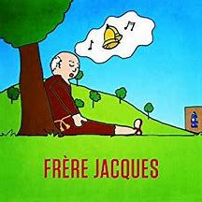
- Let’s Sing and Dance in French! By Freres Jacques
- Explain how and when you’d use the cd
I would use this CD as we are talking about the how the earth revolves and rotates around the sun. The CD would be playing as background music when we are singing and acting out the song about rotation and revolution of the earth around the sun. Hearing background music can do several things. The loudness of the background music can make the students excited. Also, the background music can help the students carry on a rhythm while singing the song. The students will be able to get their energy out by moving to the beat of the background music and sing the song along with it. Hearing the background music will help the students reduce the feeling of anxiety and stress. The background music will also regulate their emotions, as well as enhance learning and create enjoyment.
Visiting dance or movement with live performer

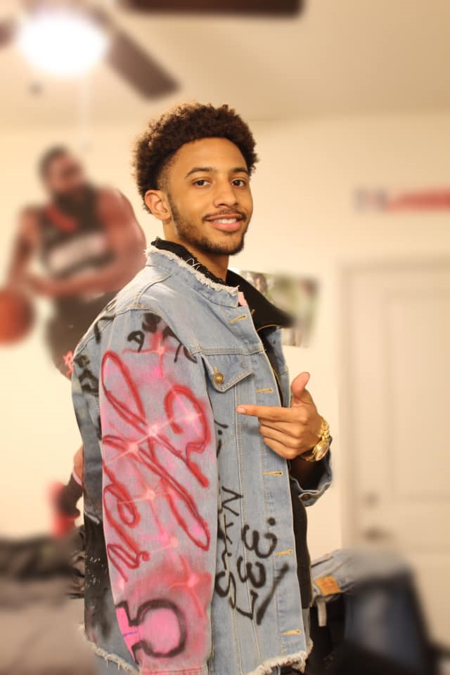
I chose Christian Hockless as my visiting live performer. Christian grew up in Atascocita, Texas. Ever since he could remember, he has been fascinated with how movies and shows were made. As a young boy, he would act out the movies and dress up as the characters. When Christian was in the 4th grade, he began asking his mom “where was this movie filmed at and how does the special effects look realistic?” While in high school, he knew he wanted to get a college degree and he knew exactly what he wanted to do as his career. He decided to attend Sam Houston State University in Huntsville, Texas to fulfill his childhood dream of becoming a movie actor or filming a movie. Christian is majoring in film and tv production. He plans on graduating with his degree in the Fall of 2020. Christian has a YouTube channel that has already helped him towards in his future goals. A movie producer in California has reached out to him. I know Christian would be a good visiting performer for my students. I would invite Christian to my class by emailing him at christianhockless@gmail.com. I would explain to Christian that it would be an amazing opportunity for my students to meet a performing artist and get his input as the class plans out their drama skit over the rotation and revolution of the earth. I would also ask Christian if he could teach my students about the importance of eye contact, pitch, and tone of voice. I would also ask him if he would share his story on how his childhood dreams are coming true. After Christian tells my students about his dreams and journey towards making those dreams a reality, I would have my students pull out their skit. Christian would teach them how to brainstorm ideas on how they might act out the play and give them tips. After they brain stormed ideas together and respectfully listened to each other’s idea, I would have Christian run through practice rounds with the students. This would help students understand how practicing and revising skits is necessary. Before Christian visits, I will encourage my students to ask questions, listen actively, follow his instructions, and be respectful. I will already have assigned my students their role in the skit, and they will know their lines in advanced. The students will each have their own copy of the lines and their speaking parts will be highlighted. We would also go over how to ask questions that are related to drama. I chose Christian because I know him personally. Christian knows his field well and knows the proper way of teaching children and adults about planning out skits. I know he loves working with children because he currently works with children at the YMCA. He enjoys teaching children how to properly plan out a skit and ways to dance according to the beat of music. The experience will be beneficial for my students because they will be learning from a trained individual in the field of drama. They will also meet a real person who has worked at making his childhood dream come true. The students will learn that hard work does pay off and dreams do come true. Hopefully the experience with Christian will inspire and encourage my students to dream big and then be willing to work to make their dreams come true.

TEKS
- §117.113. Theatre, Grade 3, Adopted 2013.
(b) Knowledge and skills. (3) Creative expression: production. The student applies design, directing, and theatre production concepts and skills. The student is expected to: (A) identify technical theatre elements such as props, costumes, sound, and visual elements that define character, environment, action, and theme; (B) use simple technical theatre elements such as props, costumes, sound, and visual elements that define character, environment, action, and theme; (C) plan dramatic play; (D) cooperate and interact with others in dramatic play; and (E) observe live or multimedia theatrical performances.
- §110.5. English Language Arts and Reading, Grade 3, Adopted 2017
(b) Knowledge and skills. (1) Developing and sustaining foundational language skills: listening, speaking, discussion, and thinking--oral language. The student develops oral language through listening, speaking, and discussion. The student is expected to: (A) listen actively, ask relevant questions to clarify information, and make pertinent comments; (B) follow, restate, and give oral instructions that involve a series of related sequences of action; (C) speak coherently about the topic under discussion, employing eye contact, speaking rate, volume, enunciation, and the conventions of language to communicate ideas effectively; (D) work collaboratively with others by following agreed-upon rules, norms, and protocols; and (E) develop social communication such as conversing politely in all situations.

Theatre floor plan and center information

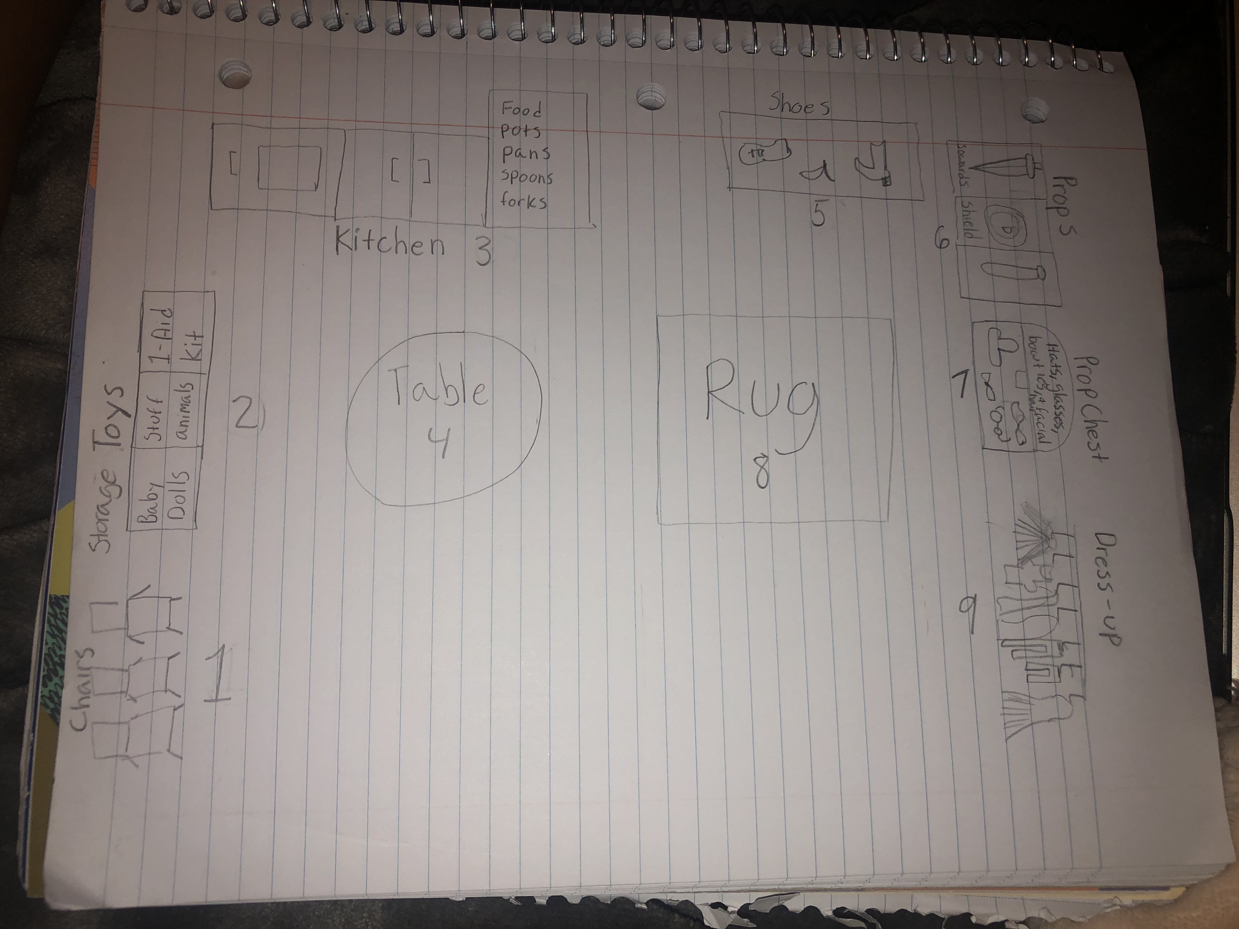

- Chair - if a student wants to sit on a chair or use the chair as part of their skit. The chairs can also be a place for the audience (other students) to sit down and give their classmates positive feedback.
- Toy Storage – The storage will have three labeled bins. The labels will boldly state what items are contained in each bin. The bins will be labeled baby dolls, stuff animals, and first aid kit. The students will be able to use the baby dolls, stuff animals, and first aid kit in their skits. The students will also be able to play with the dolls and animals independently or with one another and pretend that they are the nurse or vet.
- Kitchen - The kitchen will encourage the students to engage in play with other students. It will also allow children to discuss among each other which role each person should have and how they are going to do it. The students can also use the kitchen as part of their skit.
- Table – Students can sit at the tables to make shakers read music books, play an instrument, or just talk with friends.
- Shoes – The students can use the shoes as part of their dress up to help them get into character for their skit.
- Prop Storage- The prop storage will hold labeled bins containing certain props in each one. For example, the bin with the swords will be labeled “swords” and have a picture of what a sword looks like. This will be the same for the other two bins that contain the shield and light savors.
- Prop Chest – The prop chest will be full of hats, glasses, bowties, and facial hair that the students can use as part of their dress up.
- Rug - The rug is where the students can gather and play with different musical instruments.
- Dress up – The students will be able dress up in the drama center. Dress up clothing helps a child decide what their character might say and how they might act. I believe dress up is important in a drama center because it helps improve students’ fine motor skills, problem solving (who is going to be who), imagination, and skills needed for socializing with others.
Skills I want the students to develop

I want the students to expand their creativity, free-thinking, critical thinking, self-confidence, and curiosity. I want students to know and believe that there are not mistakes when it comes to our creativity, but only refinements that may be necessary to create the desired outcome. My goal is for students to be able to have fun while learning. I want students to develop confidence in speaking loudly and to be able to expand their comfort zones by performing or acting out characters. This assignment about how the earth moves around the sun may involve jumping, laughing, spinning, and singing. I want my students to experience fun ways of learning the material and understand that learning can occur in a variety of ways other than just reading straight out of a textbook. I want my students to be respectful to the materials (props) and their classmates. I want the students to learn how to ask other classmates for assistance and trust one another. I want my students to use the right tone and voice level, as well as being able to come to a consensus on how to act out the skit. I want my students to work together, develop their social skills. I want the students to feel comfortable and confident in their actions on the stage, as well as learn how to have the right pitch and tone for their presentation. Also, I want my students to encourage one another and provide respectful and helpful feedback. Students should learn how to ask for advice and how to give advice. Through planning and acting out the skit, the students should develop a deeper knowledge about how the earth rotates and revolves around the sun and how we get seasons and days and years.
Basic materials needed for the center

Chairs, baby dolls, stuff animals, first aid kit, play kitchen (food, pots, pans, spoons, and forks) table, shoes, swords, shields, light savors, hats, glasses, bowties, facial hair, dress up (caps, costumes, etc.) and a rug.
The purpose of the drama center is to provide students the place and means for expressing themselves in creative and imaginative ways. The center is an important place for student to experience using props they may never have seen and to be able to dress up as a character. They will also be able to experience items from different cultures. The drama center is also a perfect place for students to be able to explore new ideas and to practice them on their fellow students. The drama center provides opportunities for student to use their imagination and pretend in a way that might not be available in their home environment. It is important to have guidelines in the drama center that provide a framework for respective behavior and treatment of material but still allow students to be creative. Students will enjoy pretending and acting as characters with one another.
Guidelines
- Students will respect one another and will not speak over each other.
- Students will respect the teacher’s rules.
- Students will follow the all the school and classroom rules.
- Students will respect the visiting performer.
- Students will handle the props with care and not play roughly with them.
- Students will each be allowed to use the props that were assigned to them for their skit.
- Students will make sure they properly put the props in the right place after using them.
- Students will leave the props at school.
- Students will be respectful to one another in the center regarding the pitch and tone of their voice.
- Students will not play music loud and will ask their fellow classmates if it is okay if he or she plays music.
- Students will not pretend to be a robber or a bad guy and act violently.
Assessment instrument
Formative- Teacher will observe the students by seeing who participates in the lesson. The teacher will ask her to students to stand up and spin around and walk around a chair to gage understanding of the two key terms: rotation and revolution. The teacher will also observe the students when the class stands up and sings the rotation and revolution song and acts out the motions. While doing the assignment, the teacher will observe the students’ interactions each other. The teacher will observe the students, making sure they fully understand the assignment.
Summative- The teacher will access the students throughout the skit. The teacher will use the following rubric to assess the student’s ability to memorize, maintain great eye contact, and use the volume and pitch of their voice so everyone can hear them clearly. The teacher will also be assessing the students ability to follow directions carefully.
Rubric |  |  |  | Bonus Points
Points | 3 | 2 | 1 | 3
Memorized Lines | All their lines are memorized | Half of their lines are memorized | Only a few of their lines are memorized | Costumes were well put together
Eye Contact | Eye contact to audience was appropriate | Eye contact was appropriate at times, but lacking at other times. | Eye contact was poor
Volume and Pitch | Kept volume and pitch 100% throughout the whole skit | Volume and pitch varied throughout the skit | Volume and pitch were ineffective and audience could not hear them clearly
 |  | Total Points=

